Fundamentals Assignment by Alastair Miller

The algorithm that was used in the follow source code was insertion sort
Source code:
Imports System.Math
Imports System.Text

Module Module1
Sub Main()
Dim r As New Random
Dim list(9) As Double
Dim Nan() As Double
Dim Nanlistlength As Integer = 0
Dim menuinput As Integer = 0
Dim nan1 As Double = CreaterandomNan(r)
Dim nan2 As Double = CreaterandomNan(r)
Dim nan3 As Double = CreaterandomNan(r)
Dim minusinfinity As Double = -1 / 0
Dim negativeZero As Double = -0.0D
Dim nanstring() As String

list = {-1.0, -0.0, nan1, 5.3, nan2} 'The list to be sorted
Nan = {0}
nanstring = {""}
printpre(list) 'Calls the print subroutine and prints the list before sorting
excludeNan(list, Nan) 'Calls the subroutine to exclude NaNs from the list
insertionsort(list) 'Calls the sort subroutine
postprint(list, Nan, nanstring) 'Prints the final list

End Sub

Public Sub insertionsort(ByRef list() As Double)
If list.Length = 0 Or list.Length = 1 Then 'Checks the list length to see if its 1 or 0
Console.WriteLine("The list needs no sorting as the number of elements is " & list.Length)
End If
Dim i As Integer = 1
Dim j As Double
Dim n As Integer
For i = 1 To list.Length - 1 'The sort algorithm
j = list(i)
For n = i - 1 To 0 Step -1
If list(n) <= j Then Exit For
list(n + 1) = list(n)
Next
list(n + 1) = j
Next

End Sub
Public Sub printpre(ByVal list() As Double)

Dim counter As Integer = 0
For i = 0 To list.Length - 1 ' Goes through the list and prints all items
counter = i
printproperthing(list, counter)
Next
Console.WriteLine()
End Sub
Public Sub postprint(ByVal list() As Double, ByVal nans() As Double, ByRef nanstring() As String)
Dim counter As Integer = 0
Console.WriteLine("Numbers that are not Nans: ") 'Prints the sorted list
For i = 0 To list.Length - 1
counter = i
printproperthing(list, counter)
Next
Console.WriteLine()
Console.WriteLine("Nans: ") 'Prints all of the sorted nans
Nansort(nans, nanstring)
For i = 0 To nanstring.Length - 1
counter = i
Console.WriteLine(nanstring(i))
Next

End Sub
Public Sub excludeNan(ByRef list() As Double, ByRef nan() As Double)
Dim Nanlistlength As Integer = 0
Dim Q As Integer = 0
Dim i As Integer
Dim nantemp As New List(Of Double)
Dim listtemp As New List(Of Double)
listtemp = list.ToList 'The list is copied into a temporary list
Q = listtemp.Count
Do While i < Q
If Double.IsNaN(listtemp.Item(i)) Then
nantemp.Add(listtemp.Item(i))
listtemp.RemoveAt(i) 'If a NaN is found the remove the Nan from the list
Q = listtemp.Count 'The new count is noted
Else
i += 1
End If
Loop
list = listtemp.ToArray()
nan = nantemp.ToArray()
End Sub
Public Sub Nansort(ByRef Nan() As Double, ByRef nanstring() As String)
ReDim nanstring(Nan.Length - 1)
For i = 0 To Nan.Length - 1
Dim number = Nan(i) 'Converts the Nans to Binary strings
Dim numberAsLong As Long = BitConverter.DoubleToInt64Bits(number)
Dim numberInBinary As String = Convert.ToString(numberAsLong, 16) ' 16= means base 16
nanstring(i) = numberInBinary
Next
Dim a As Integer = 1
Dim j As String
Dim n As Integer
For a = 1 To nanstring.Length - 1 ' Uses the sort to sort the Hex Strings
j = nanstring(a)
For n = a - 1 To 0 Step -1
If nanstring(n) <= j Then Exit For
nanstring(n + 1) = nanstring(n)
Next
nanstring(n + 1) = j
Next

End Sub
Public Sub printproperthing(ByVal list() As Double, ByVal counter As Integer)
If list(counter) = 0 Then 'If selected element is 0'
Dim number As Double
number = list(counter)
Dim numberAsLong As Long = BitConverter.DoubleToInt64Bits(number)
Dim numberInBinary As String = Convert.ToString(numberAsLong, 2) 'Converts the element into its bit pattern'
If numberInBinary.First = "1" Then 'If the first bit in the bit pattern is 0 then the number is -0'
Console.Write("-0, ")
Else 'otherwise the number must be zero'
Console.Write("0, ")
End If

ElseIf list(counter) = Double.NegativeInfinity ' Captures Negative infinity and outputs "Negative Infinity" string instead of -8
Console.Write("Negative Infinity,")
ElseIf list(counter) = Double.PositiveInfinity ' Captures Postive infinity and outputs "Positive Infinity" string instead of 8
Console.Write("Positive Infinity,")
Else
Console.Write(list(counter) & ", ") ' else print the number
End If
End Sub
Function CreaterandomNan(ByVal r As Random)
Dim s As String = "0123456789ABCDEF" 'The range of characters that can be chosen
Dim sb As New StringBuilder
Dim nan As String
sb.Append("FFF") ' First 3 characters must be FFF, puts it in the NaN range
For i As Integer = 3 To 15 ' Builds up the Hex Nan
Dim idx As Integer = r.Next(0, 16) 'Picks a character from the the string
sb.Append(s.Substring(idx, 1))
Next
nan = sb.ToString()
Dim number = nan 'Converts the string to Double
Dim numberAsLong As Long = Convert.ToInt64(nan, 16)
Dim numberAsDouble As Double = BitConverter.Int64BitsToDouble(numberAsLong)
Return numberAsDouble
End Function
End Module

- Give the input and output of a program run that proves it can sort an empty list. [5 Marks]

list = {}
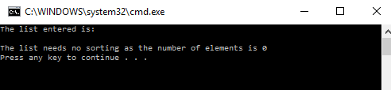
- Give the input and output of a program run that proves it can sort a list of one element. [5 Marks]
list = {1}
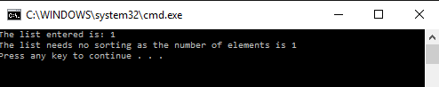
- Give the input and output of a program run that proves it can sort a list of a variable number of elements. [5 Marks]
list = {5, 2, 4, 5, 1,9}
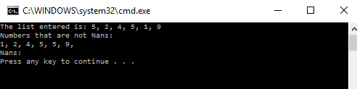

list = {5, 2, 4, 5, 1, 9, 423, 4212}
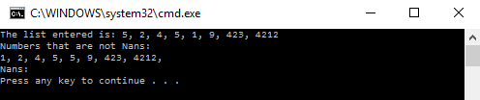

- Give the output of a program run that proves it can generate minus zero as a floating-point object that is not identical to zero. [5 Marks]
list = {1.0, -0.0, -1.0, 0.0}
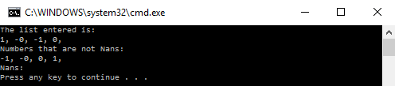

- Give the output of a program run that proves it can generate one NaN. [5 Marks]
Dim nan1 As Double = CreaterandomNan(r)
list = {1.0, -0.0, -1.0, 0.0, nan1}
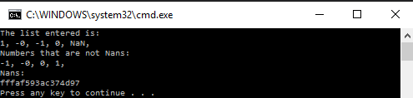
- Give the output of a program run that proves it can generate multiple, different NaNs. [5 Marks]
Dim nan1 As Double = CreaterandomNan(r)
Dim nan2 As Double = CreaterandomNan(r)
Dim nan3 As Double = CreaterandomNan(r)
list = {1.0, -0.0, -1.0, 0.0, nan1, nan3, nan2}
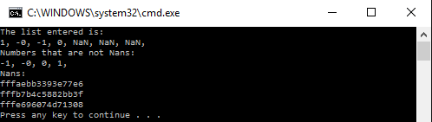
- Describe how your program sorts negative zero relative to zero and the other floating-point numbers. [5 Marks]
Although there is a distinction between -0 and 0 for IEEE floating-point numbers, they are both stored as 0 in arrays. Therefore they appear to be identical and therefore -0 and 0 cannot be sorted. But this is not the case as the -0 value has a different bit pattern compared to 0. Therefore I converted all 0’s in the list to their bit pattern and then made a comparison. As -0 cannot be stored in an array I did this comparison at the printing stage.
Public Sub printproperthing(ByVal list() As Double, ByVal counter As Integer)
If list(counter) = 0 Then 'If selected element is 0'
Dim number As Double
number = list(counter)
Dim numberAsLong As Long = BitConverter.DoubleToInt64Bits(number)
Dim numberInBinary As String = Convert.ToString(numberAsLong, 2) 'Converts the element into its bit pattern'
If numberInBinary.First = "1" Then 'If the first bit in the bit pattern is 0 then the number is -0'
Console.Write("-0, ")
Else 'otherwise the number must be zero'
Console.Write("0, ")
End If

- Describe how your program sorts different NaNs relative to each other and to the floating-point numbers. [5 Marks]
First the NaNs are removed from the main list, so that they can be sorted independently from the rest of the floating point numbers. Then the NaNs are converted to their hex bit patterns this means they can be sorted relative to each other, and then fed into the sorting algorithm. After they have been sorted.
For i = 0 To Nan.Length - 1
Dim number = Nan(i) 'Converts the Nans to Binary strings
Dim numberAsLong As Long = BitConverter.DoubleToInt64Bits(number)
Dim numberInBinary As String = Convert.ToString(numberAsLong, 16) ' 16= means base 16
nanstring(i) = numberInBinary
Next
This code shows how the NaNs are converted to binary.
- Give the input and output of a program run that proves it can sort multiple repetitions of a single NaN in a list of floating-point numbers. [5 Marks]
Dim nan1 As Double = CreaterandomNan(r)
list = {1.0, -0.0, -1.0, 0.0, nan1, nan1, nan1}
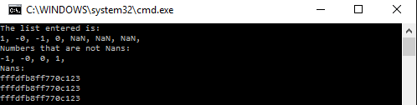
- Give the input and output of a program run that proves it can sort multiple repetitions of different NaNs in a list of floating-point numbers. [5 Marks]
Dim nan1 As Double = CreaterandomNan(r)
Dim nan2 As Double = CreaterandomNan(r)
Dim nan3 As Double = CreaterandomNan(r)
list = {1.0, -0.0, -1.0, 0.0, nan1, nan3, nan1, nan3}
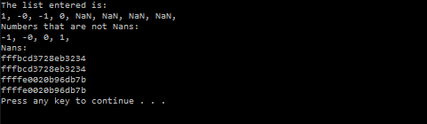
- Use any machine method to report the time taken for the sorting program to run on a list of data. [5 Marks]
Dim stopwatch1 As New Stopwatch
stopwatch1.Reset
stopwatch1.Start()
excludeNan(list, Nan) 'Calls the subroutine to exclude NaNs from the list
insertionsort(list) 'Calls the sort subroutine
stopwatch1.Stop()
Console.WriteLine("The time taken is : {0}", stopwatch1.Elapsed)
- Produce a table of list length versus time taken to sort lists. [5 Marks]
Number of elements | Time taken to sort (1)(ms) | Time taken to sort (2)(ms) | Time taken to sort (3)(ms) | Time taken Average (ms)
1 | 9 | 9 | 9 | 9
10 | 10 | 11 | 11 | 11
100 | 13 | 13 | 13 | 13
1000 | 25 | 26 | 26 | 26
10000 | 208 | 209 | 209 | 209
100000 | 16449 | 16449 | 16449 | 16449
1000000 | 4689728 | 4689728 | 4689728 | 4689728

- Produce a graph of list length versus time taken to sort lists. [5 Marks]

- Give a recurrence relation that describes the time order for the worst-case of the sorting algorithm. [5 Marks]

- Solve the recurrence relation that gives the time order for the worst-case of the sorting algorithm. [5 Marks]

- Compare the theoretical and actual performance of you program. Is the theory supported by the evidence? If not, what might explain the discrepancy? [5 Marks]
The actual performance is lower than the theoretical performance because extra nested loops where added for example, another loop was added to exclude all NaNs from the list. The instructions to check the list will also decrease from the efficiency. Each nested loop adds one to the power of the time order.
- Test a built-in sort procedure. Does it correctly handle minus zero and NaNs? [5 Marks]
list = {-1.0, -0.0, nan1, 5.3, nan2} 'The list to be sorted
Array.Sort(list)
For i = 0 To 4
Console.WriteLine(list(i))
Next
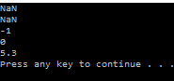
Although the program does not produce a fatal error it does not properly handle -0 as it outputs 0. Also it is impossible to tell if the NaNs have been sorted correctly as the console does not output a numerical value to check the comparison was correct.
- Test a built-in sort procedure. What time order does it appear to have? [5 Marks]
As it cannot be proven without extra steps that the inbuilt sort function can sort NaNs, the list was just made up of floating point numbers
Elements in list | Time taken to sort (1) (ms) | Time taken to sort (2) (ms) | Time taken to sort (3) (ms) | Time taken to sort average (ms)
1 | 0.00332 | 0.00337 | 0.00229 | 0.00299
10 | 0.00547 | 0.00484 | 0.00426 | 0.00485
100 | 0.00541 | 0.00553 | 0.00615 | 0.00569
1000 | 0.313 | 0.2396 | 0.24 | 0.2642
10000 | 2.2935 | 2.2832 | 2.2662 | 2.4129
100000 | 14.44 | 14.35 | 14.75 | 14.513
1000000 | 23.67 | 25.94 | 28.56 | 26.057

It was not obvious what the time order was as it seemed to change at around 1000 elements, so more research was carried out into the inbuilt search function.

According to msdn.microsoft.com:

- If the partition size is fewer than 16 elements, it uses an insertion sort algorithm.
- If the number of partitions exceeds 2 * LogN, where N is the range of the input array, it uses a Heapsort algorithm.
- Otherwise, it uses a Quicksort algorithm.

- Bonus for anything that is done particularly well. [10 Marks]

“Insertion Sort” http://www.personal.kent.edu/~rmuhamma/Algorithms/MyAlgorithms/Sorting/insertionSort.htm Date accessed: 10/02/2016

